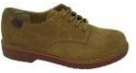
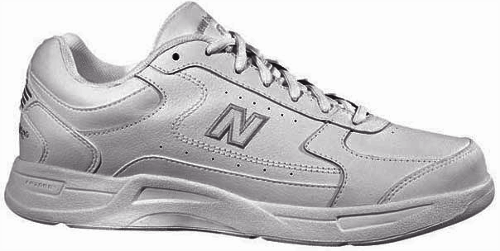
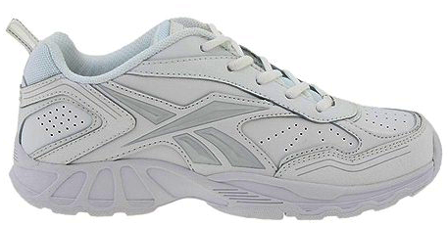
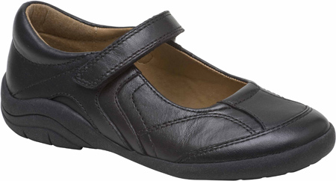
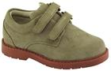
Flocco’s Shoes & Clothes

Professionally Fitted Since 1926

Phone: (610) 828-5544 www.Floccos.com 110-114 Fayette Street Conshohocken, PA 19428
Shoe StylesSizesPriceNew Balance (All White)Children10 - 635.00New Balance (All White)Adult6 1/2 - 1354.00Reebok (All White) Back To It IIChildren10 to 635.00Reebok (All White)Adults6 1/2 - 1355.00Bass Buc / AcademyChildren10 - 1234.00Bass Buc / AcademyChildren12 1/2 - 637.00Bass Buc / AcademyMen6 1/2 - 1547.00Bass Buc / AcademyWomen5 - 1145.00
Pope John Paul II

Flocco’s will make a donation for each pair of shoes sold to your school!
Official uniform price list
Flocco’s will be at Pope John Paul II School
Tuesday July 16th From 4:00 PM - 7:00 PM

All regulation shoes can be purchased at this time. If you are unable to attend the day of the sale, we will be in your area at other times.Please check our website www.Floccos.com
SHOE SALE
Stride Rite Mary JaneChildren10 - 442.00School issue VelcroChildren10 - 1335.00

